**DAILY ONLINE ACTIVITIES SUMMARY**

|  |  |  |  |  |  |  |  |  |
| --- | --- | --- | --- | --- | --- | --- | --- | --- |
| **Date:** | **18/05/2020** | | | | | **Name:** | **Hanan Saleem Baji** | |
| **Sem & Sec** | **4th SEM 'A' Section** | | | | | **USN:** | **4AL18CS024** | |
| **Online Test Summary** | | | | | | | | |
| **Subject** | | **Complex Analysis, Probability theory and Statistics** | | | | | | |
| **Max. Marks** | | **30** | | **Score** | | | **NA** | |
| **Certification Course Summary** | | | | | | | | |
| **Course** | **1.Python In Machine Learning** | | | | | | | |
| **Certificate Provider** | | | **1. Great Learning Academy** | | **Duration** | | | **1. 45 min** |
| **Coding Challenges** | | | | | | | | |
| **Problem Statement:** 1. An Anagram of a string is another string that contains same characters, only the orders of characters can be different.  For example, “act” and “cat” are anagram of each other.  2. Given an array of distinct integers. The task is to count all the triplets such that sum of two elements equals the third element.  For example | | | | | | | | |
| **Status: completed** | | | | | | | | |
| **Uploaded the report in Github** | | | | | **Yes** | | | |
| **If yes Repository name** | | | | | <https://github.com/saleemhananbaji/lockdown-coding> | | | |
| **Uploaded the report in slack** | | | | | **Yes** | | | |

ONLINE TEST DETAILS: Online test was conducted on the fourth module of Maths. Test contains 30 questions of 1 Mark each.

Certification Course Details: I have started with Python in Machine learning course. Firstly, they have given Introduction to Python. It includes what is python, IDE of Python, Anaconda installation and Jupyter Notebook.

Snapshot:

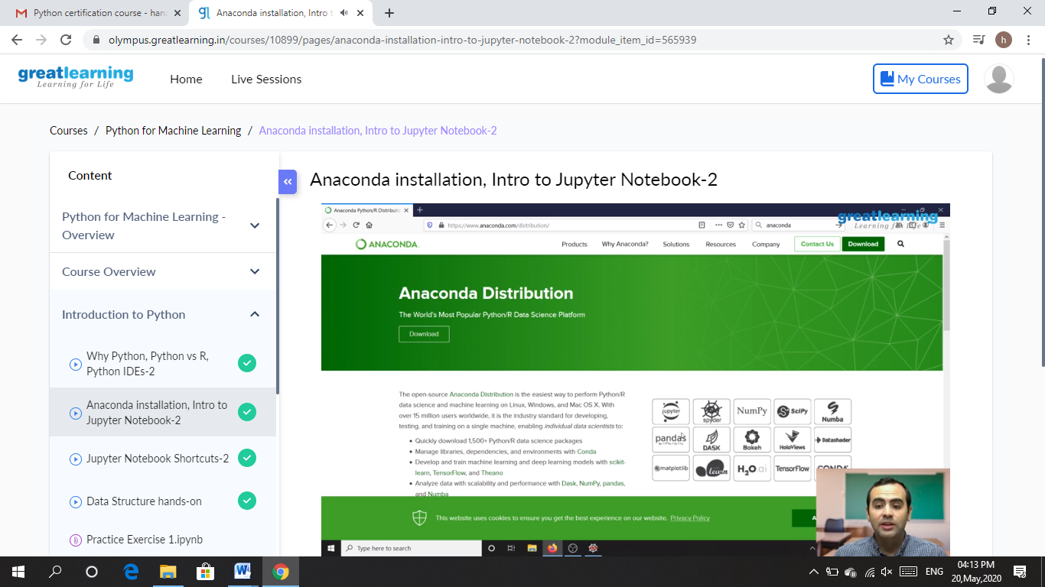

CODING CHALLENGES DETAILS: Problem statements

1. An Anagram of a string is another string that contains same characters, only the orders of characters can be different.

For example, “act” and “cat” are anagram of each other.

Solution : Uploaded it in github

Snapshot:

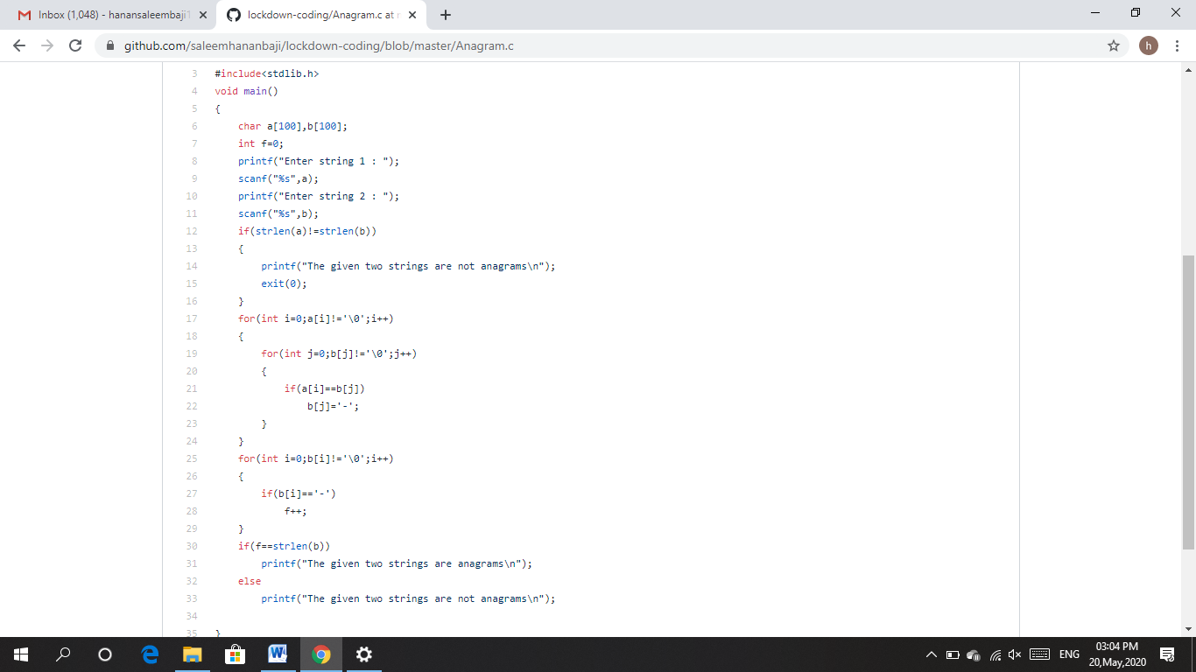

1. Given an array of distinct integers. The task is to count all the triplets such that sum of two elements equals the third element.

Solution : Uploaded it in github

Snapshot:

